Reference determination

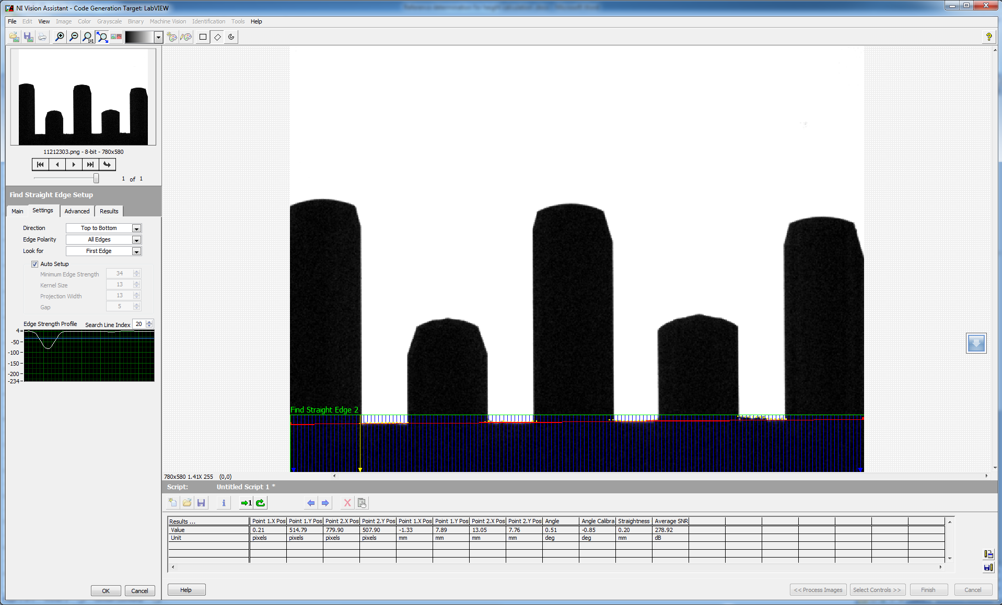

The 0.5 degree tilt of the OUI effected the line fit. It produced a difference of 4-5 pixels between end points of the line

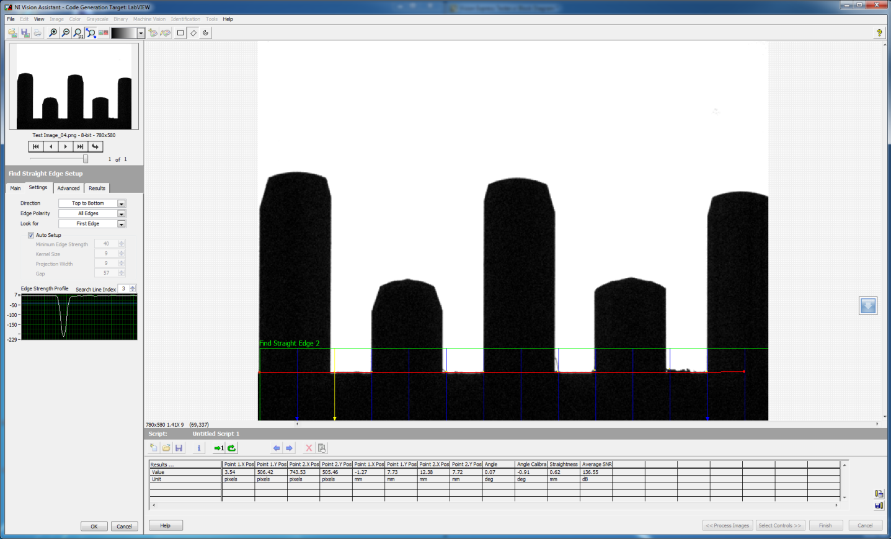

After the tilt is adjusted, the line fit was more approximate to a straight line. . It produced a difference of 1-2 pixels between end points of the line.

